Table 1. Results of total thiamine levels detected in chinook salmon eggs treated or untreated with thiamine.
Analysis ID |  | Total Thiamine Levels in Eggs (nmol/g)
Analysis ID |  | Cheakamus Chinook Salmon |  |  | Middle Shuswap Chinook Salmon
 |  | Control - Untreated | Thiamine-Bath Treated |  | Broodfish Injection-Treated
Test-1 |  | 11.4 | 256.8 |  | 16.1
Test-2 |  | 4.2 | 313.9 |  | 20.1
Test-3 |  | 13.9 | 327.0 |  | 27.2
Test-4 |  | 14.0 | 312.4 |  | 18.7
Mean ± SD |  | 10.8 ± 4.6 | 302.5 ± 31.2 |  | 20.5 ± 4.8
The results shown above were the mean of duplicates. Each test represented results of eggs collected from an individual fish of each population. Note that for Cheakamus chinook salmon, each pair of control and treated eggs (same row) was collected from the same fish. All Middle Shuswap chinook salmon were treated with injection prior to spawning, and thus untreated eggs were not available for sampling. The bath-treated eggs were all fertilized, while the untreated eggs, and the injection-treated eggs were not fertilized.

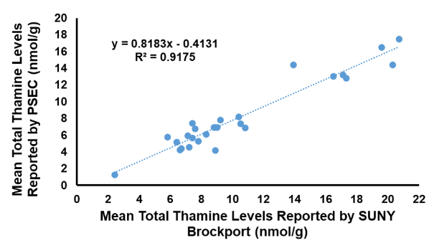
Figure 1. Results of linear regression analysis on the total mean thiamine level results reported by SUNY Brockport and PSEC on the same set of chinook salmon eggs. Each dot represents an individual sample.

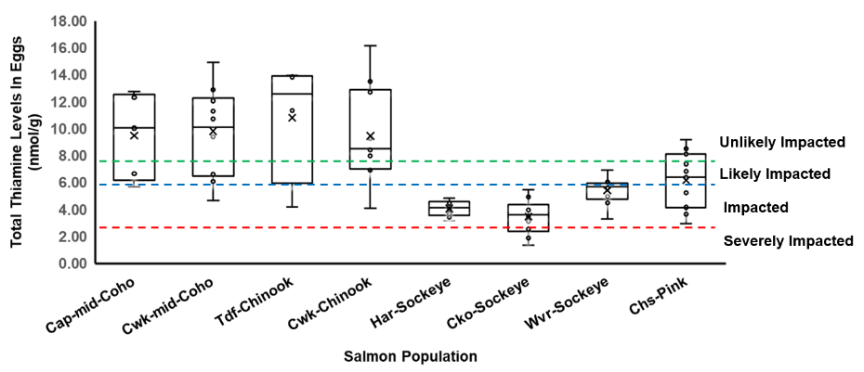

Figure 2. Results of the total thiamine levels in untreated and unfertilized eggs collected from Capilano mid coho (Cap-mid-Coho, n=5), Chilliwack mid coho (Cwk-mid-Coho, n=10), Tenderfoot Cheakamus Chinook (Tdf-Chinook, n=4), Chilliwack fall Chinook (Cwk-Chinook, n=10), Harrison sockeye (Har-Sockeye, n=10), Chilko sockeye (Cko-Sockeye, n=10), Weaver sockeye (Wvr-Sockeye, n=9) and Chehalis pink (Chs-Pink, n=11). Note that the Harrison sockeye eggs were considered not ripe during sample collection; Tenderfoot Cheakamus Chinook data came from results of untreated eggs reported in Table 1. The dash lines represent thiamine level thresholds established by Mantua et al. (2025) to illustrate the likelihood of being impacted by thiamine deficiency: high - unlikely impacted (> 7.7 nmol/g), intermediate - likely impacted (5.9-7.7 nmol/g), low - impacted (2.7-5.9 nmol/g) and critically low - severely impacted (< 2.7 nmol/g). The cross symbol (×) in the box plot indicates mean values within each group.

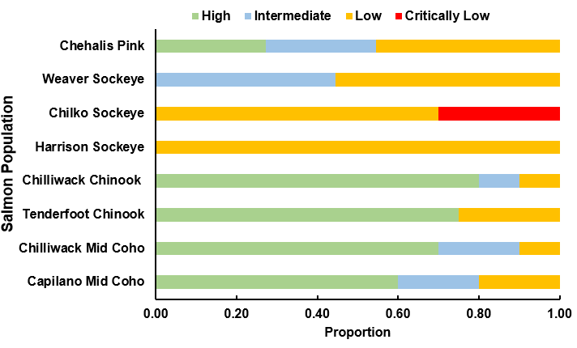
Figure 3. Proportion of salmon eggs from different populations measured by the thiamine level thresholds established by Mantua et al. (2025). Different category of total thiamine level represents different likelihood of being impacted by thiamine deficiency: high - unlikely impacted (> 7.7 nmol/g), intermediate - likely impacted (5.9-7.7 nmol/g), low - impacted (2.7-5.9 nmol/g) and critically low - severely impacted (< 2.7 nmol/g). Eggs were collected from different salmon species and population: Capilano mid coho (n=5), Chilliwack mid coho (n=10), Tenderfoot Cheakamus Chinook (n=4), Chilliwack fall Chinook (n=10), Harrison sockeye (n=10), Chilko sockeye (n=10), Weaver sockeye (n=9) and Chehalis pink (n=11).

